Online Learning Agreement (OLA)
for Erasmus+ incoming exchange students

Dear student,

The Online Learning Agreement is now mandatory at Université Paris 1 Panthéon-Sorbonne for Erasmus+ incoming exchange students in Economics, History and Management only. It is not mandatory if you are an Erasmus+ incoming exchange student in other departments unless your institution asks you to fill in an Online Learning Agreement. In that case, please follow the instructions below and find the list of people in charge of signing your OLA in each department of Paris 1 Panthéon-Sorbonne on page 3.

You are now about to fill in your Online Learning Agreement (OLA). You will have to sign in the OLA platform, using the link below. This online tool is now used by Paris 1 Panthéon-Sorbonne in order to allow you to save time if you have to adjust the document; it also allows us to transition to a paperless process, thus facilitating the work of any person working on filling in or signing your learning agreement. You will find here the list of courses.

https://learning-agreement.eu/

Please read carefully the instructions below beforehand.

- It is extremely important that you correctly fill in the information on the Responsible Person (names and email addresses) from both your sending and host universities. Indeed, these emails will be used by the OLA system to automatically send your OLA to home and host universities once you signed it. Please refer to the document on page 3 to find the contact person and the responsible person in your department at Paris 1 Panthéon-Sorbonne.

- No paper version of your learning agreement will be signed. You will have to upload your OLA on MoveON once it is signed online by the three parties (you, your sending institution, your receiving institution). Please do not download your OLA before it is signed.

- It can take up to 10 days for your learning agreement to be signed. Thank you for your understanding.

- The Sorbonne School of Economics, the Sorbonne School of History and the Sorbonne Management School will also accept to sign your learning agreement in a paper version in case your university is not familiar with the OLA and asks for it: in that case the choice of courses will have to be exactly the same on both documents.

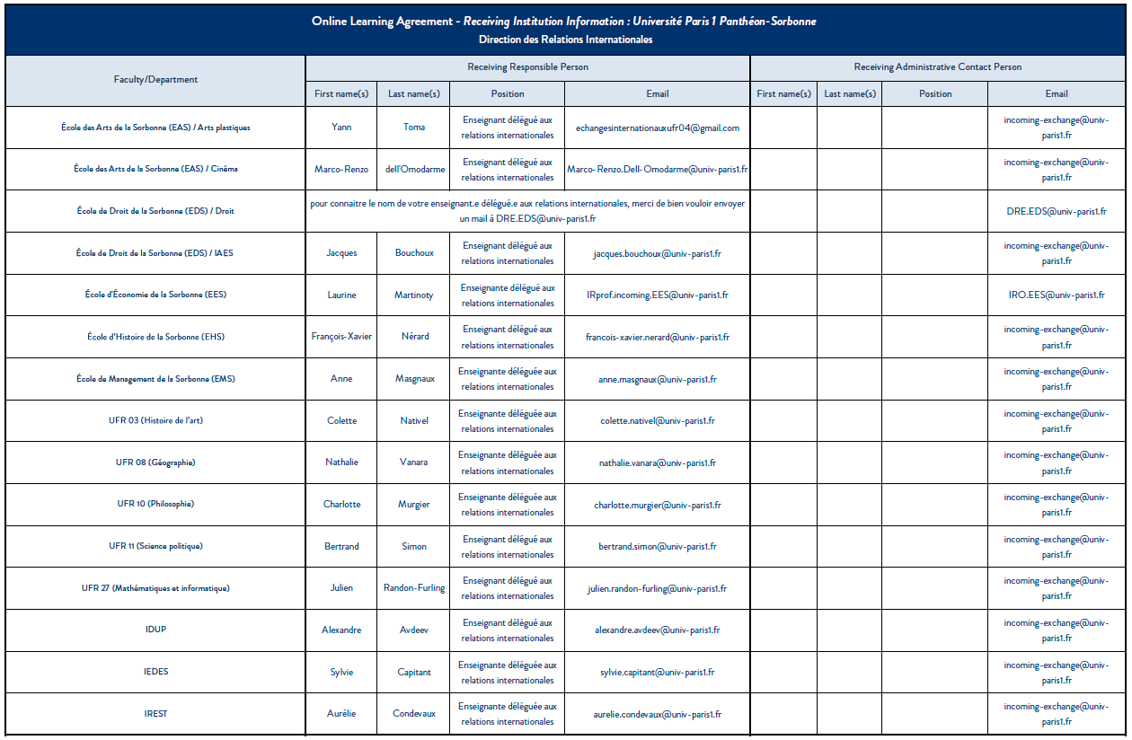

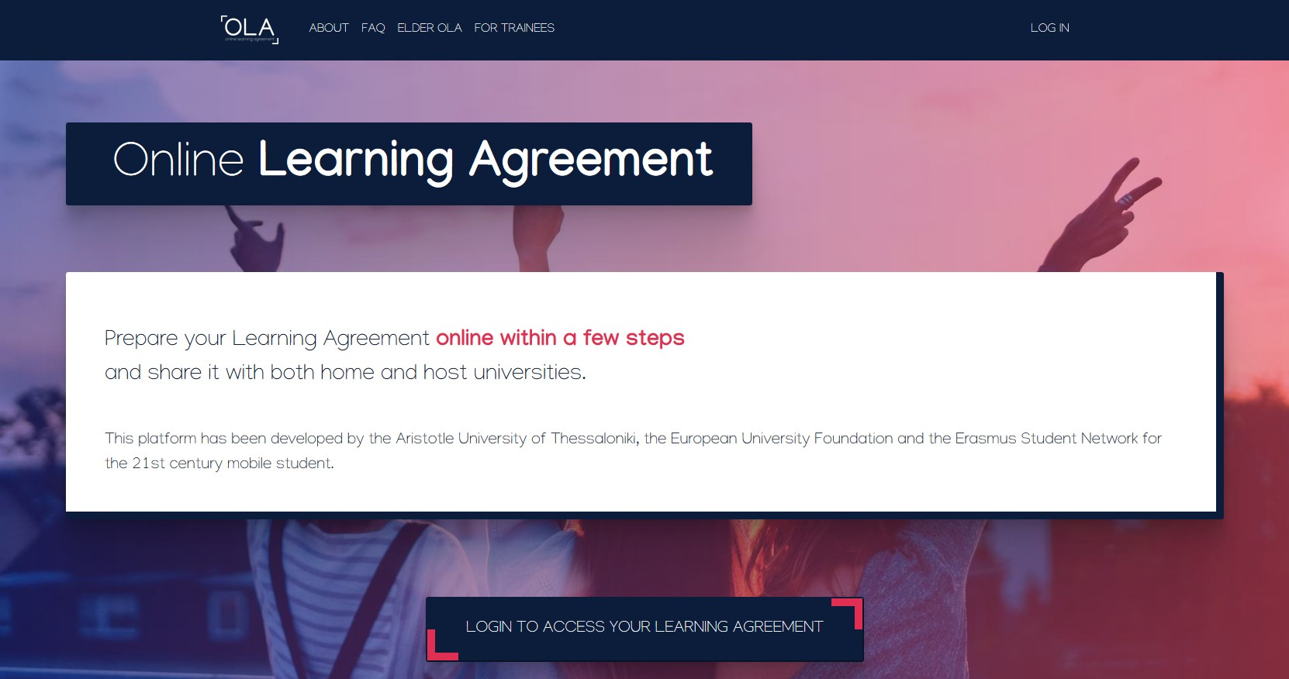
If this is your first use of the OLA, please create an account by clicking on LOG IN.

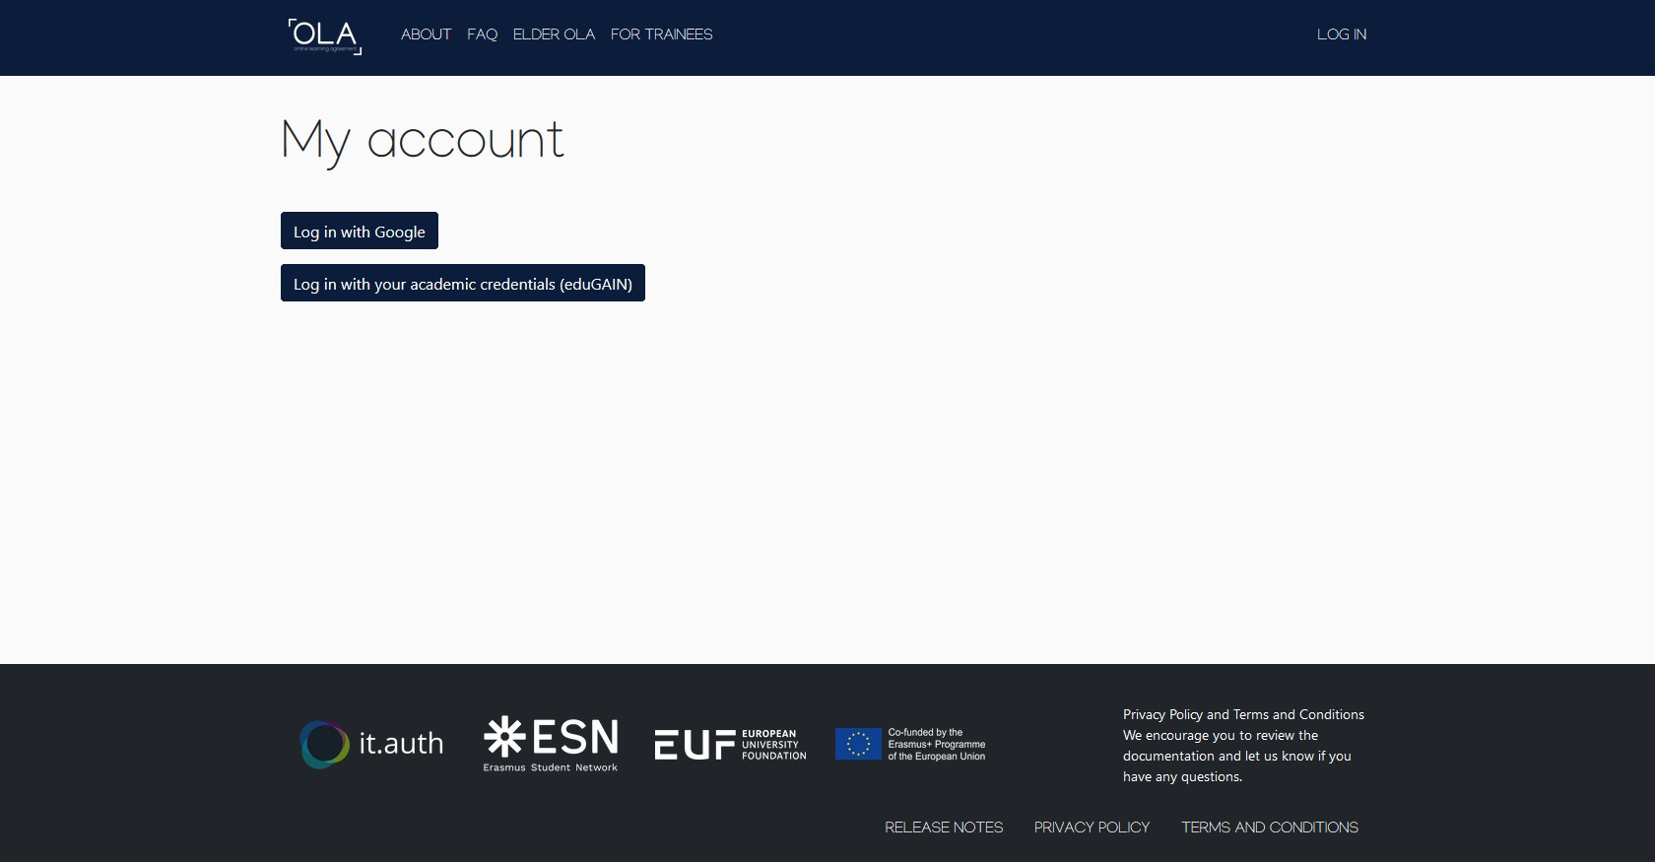
Choose one of the options to access the OLA platform.
Logins made through Google accounts will probably be accepted until Spring 2021 only.
The second option allows you to access the OLA platform using your academic credentials or eduGAIN. In case you do not know if you have an eduGAIN account, ask your coordinator if your home institution is already part of the eduGAIN community and how you can get your credentials. When you sign up, you are going to receive an activation email. For your information, it might take a few minutes for the activation email to be sent. Do not forget to check also your spam folder.

Students who already have or have initiated an OLA before October 17th can still access it through the previous platform by clicking on ELDER OLA.

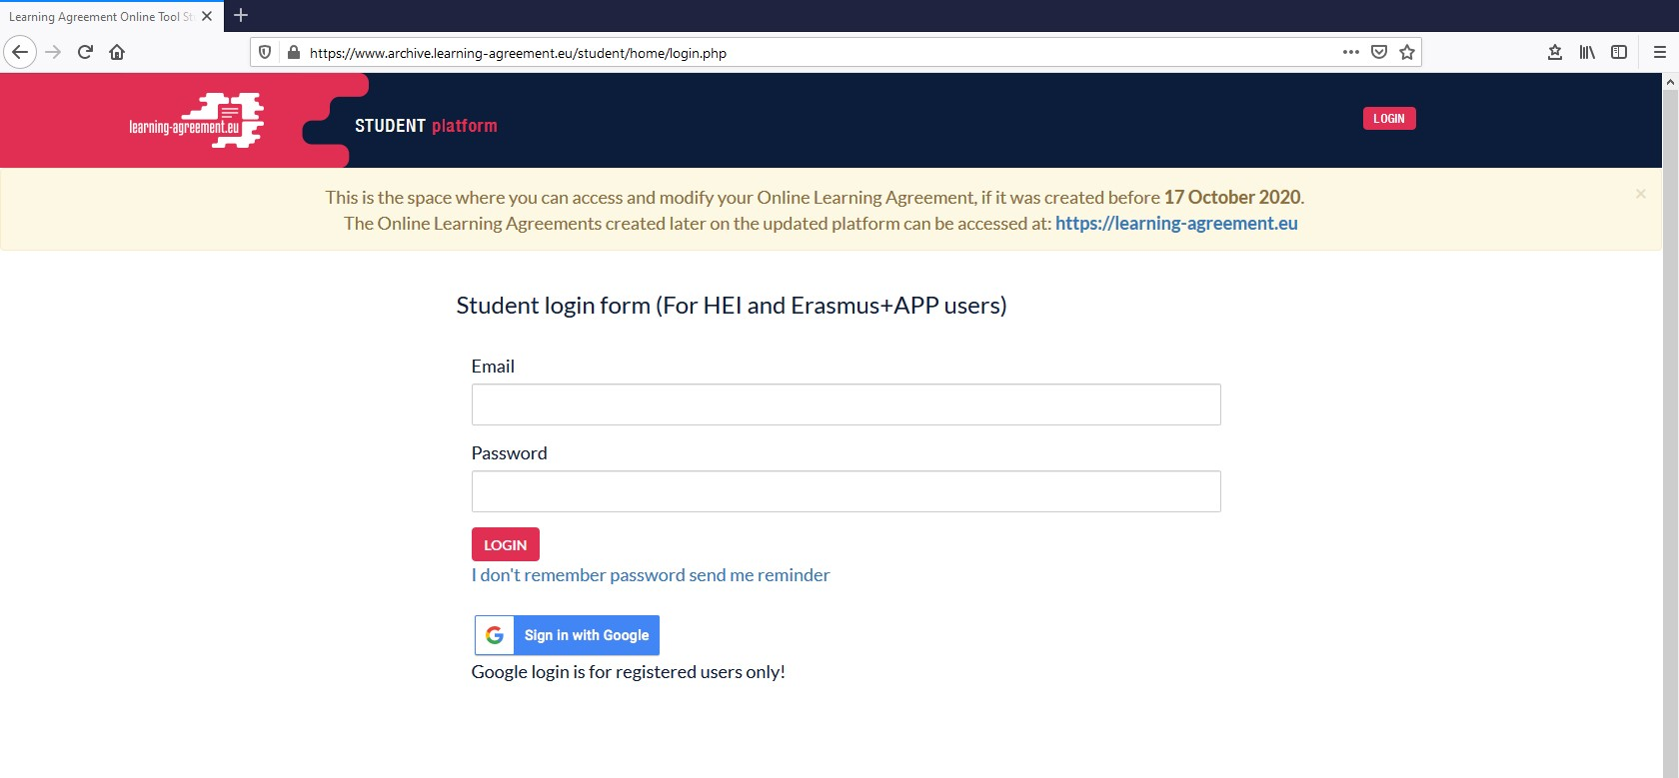
Only students who have already created an account, initiated or finalised an OLA before October 17th can access the previous platform with their existing login credentials to modify or download their OLA.

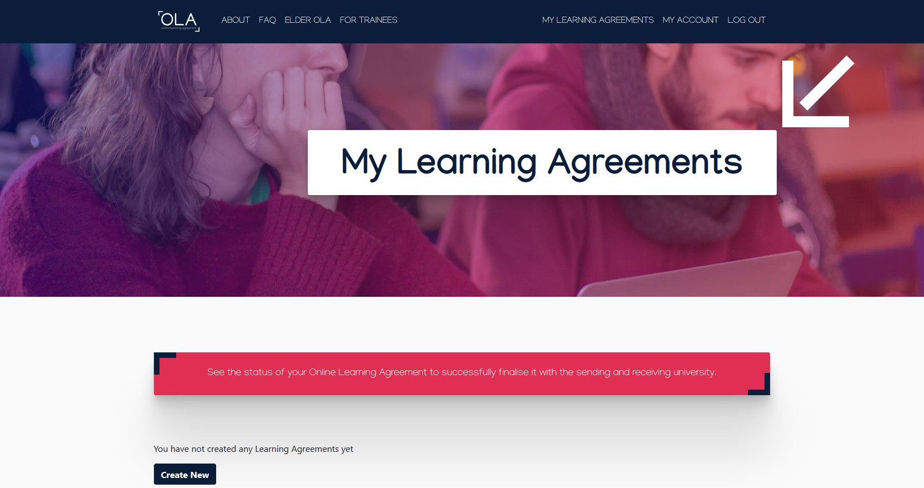
To start with your OLA, please click on Create New.

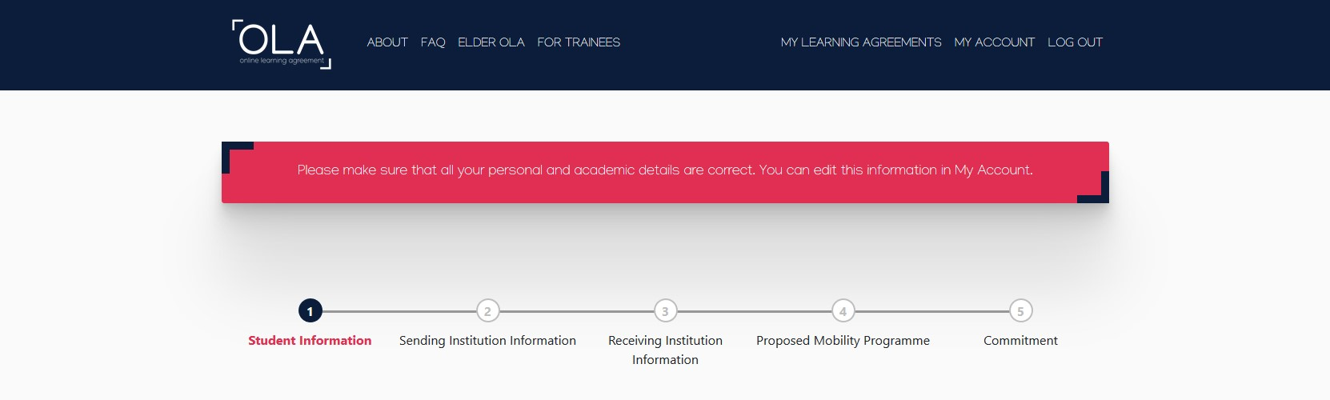

1. Student Information
Your personal and academic details will be pre-filled on each new OLA with the information you provided when you logged in for the first time.

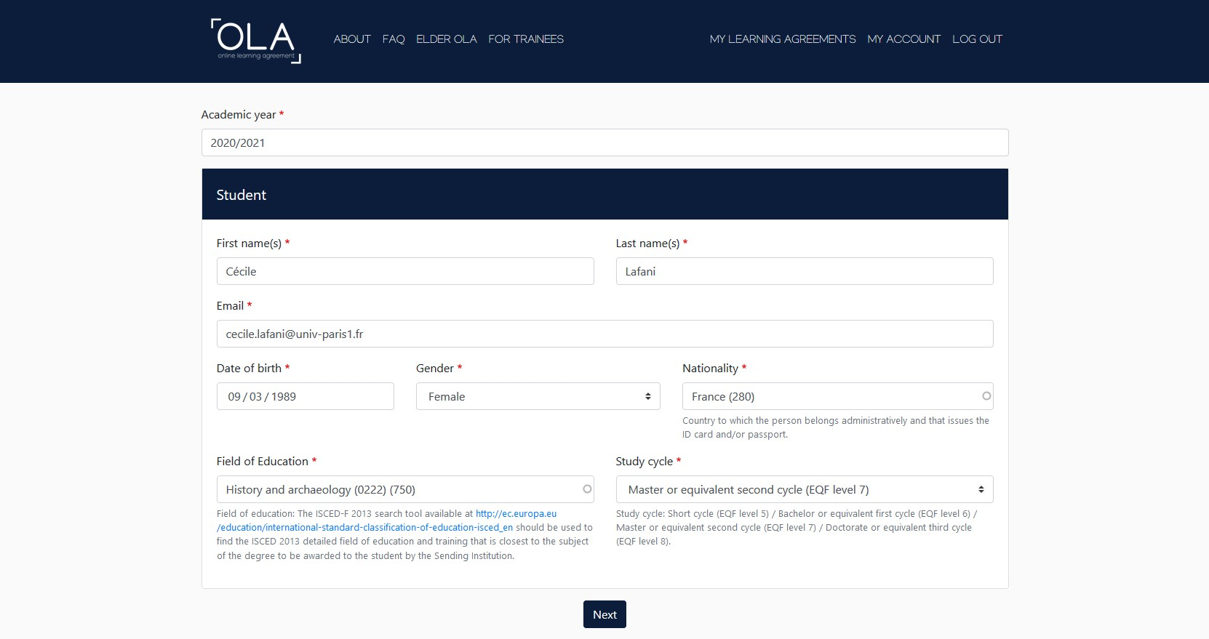
You can edit your personal and academic details by clicking on MY ACCOUNT.
You can change the academic year, if needed.
For example:
0222 – History and archeology
0311 – Economics
0413 – Management and administration

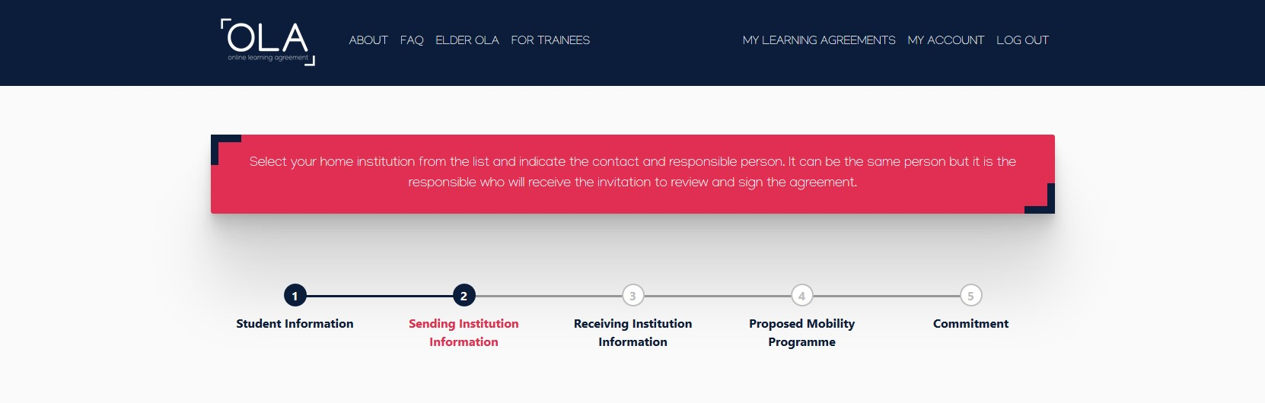

2. Sending Institution Information

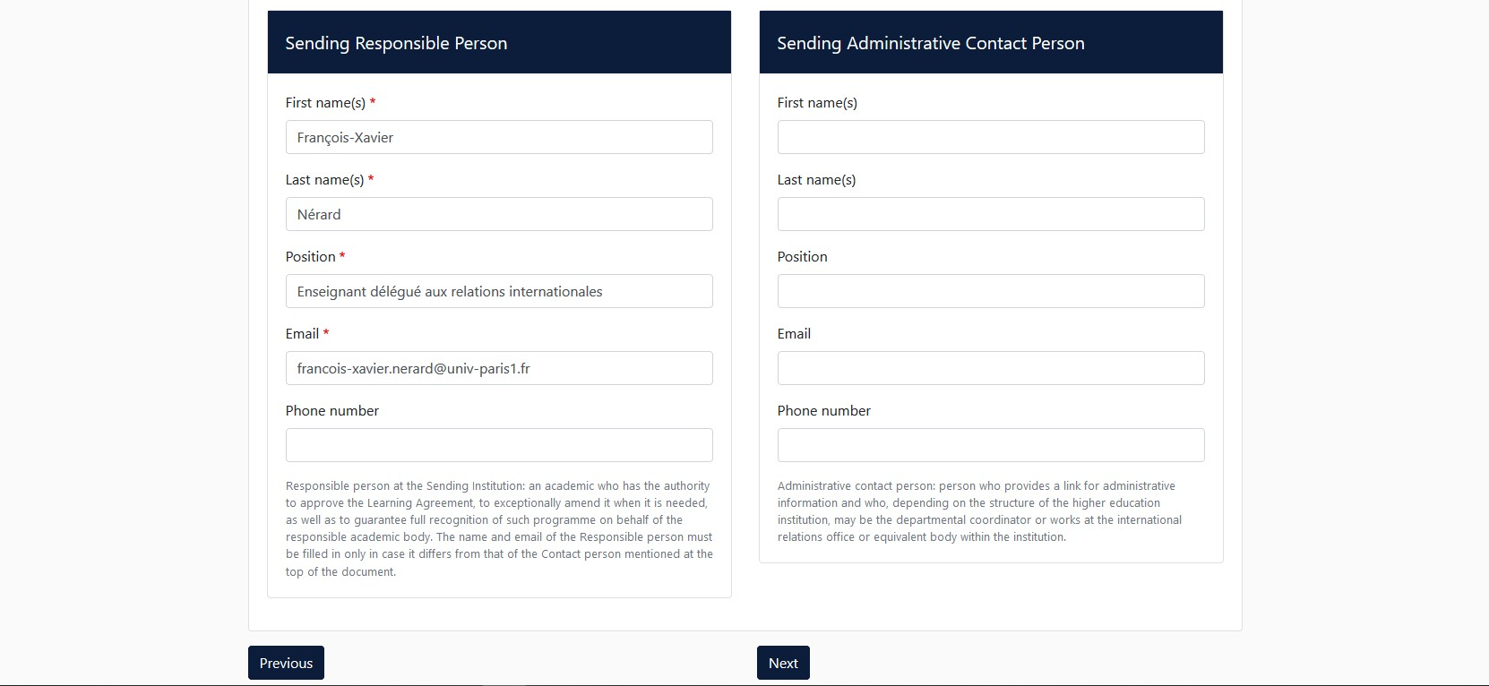
Please contact your home institution to know who is the Responsible Person in charge of signing your learning agreement. Make sure you write the correct name and email address. Otherwise, your learning agreement will not be signed.

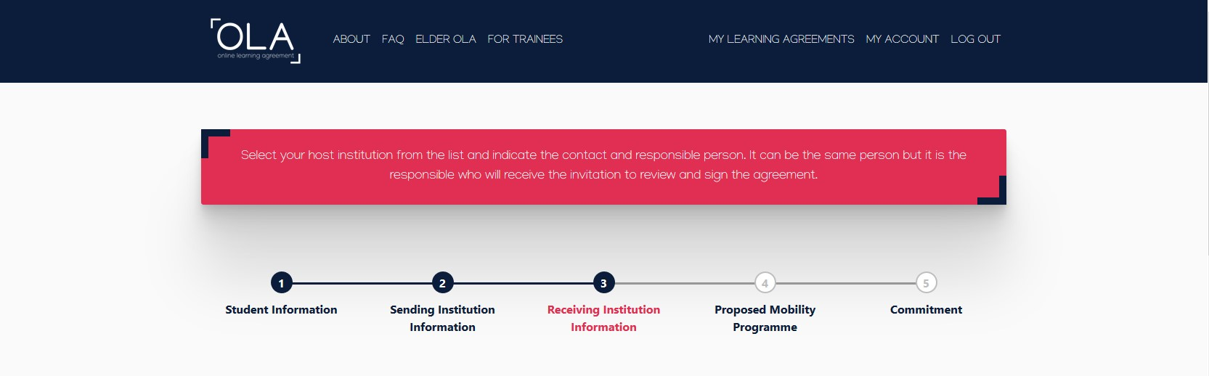

3. Receiving Institution Information

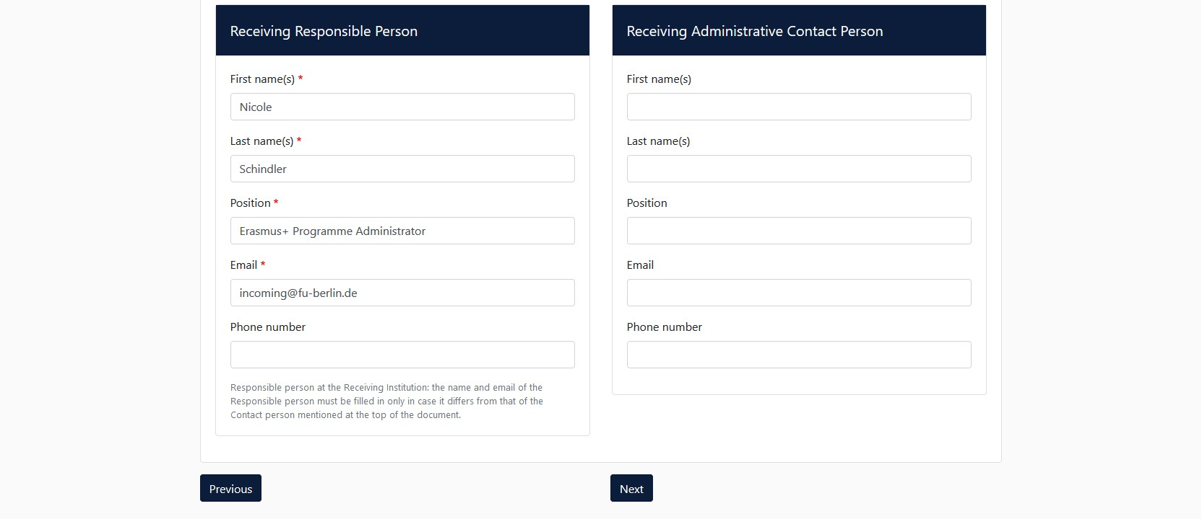
Please carefully fill in these fields with the information provided in the list on page 3.

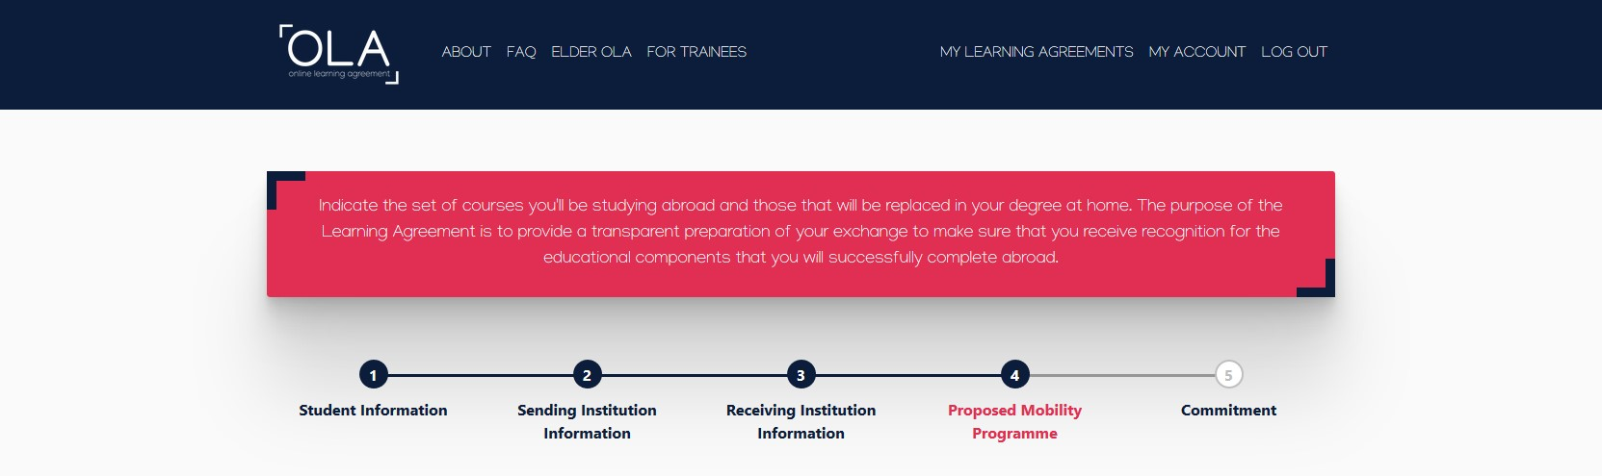

4. Proposed Mobility Programme

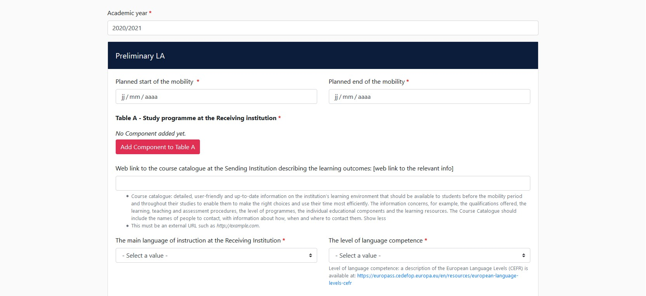
Please pay attention to the fact that your learning agreement will not be signed if the component titles and, more importantly, the component codes are incorrect. Some courses from Bachelor degree have the same title as some courses from Master degree, but the codes are different. Make sure you also indicate the number of ECTS for each course. If you find courses matching your academic profile you can add them to your OLA.

In Table A, please add as many subjects as you will take at Paris 1 Panthéon-Sorbonne by clicking on Add Component to Table A.
If your curriculum includes an optional module, please add a subject and title it “Bloc libre”. The number of ECTS for this line has to be the same as the total of ECTS you will obtain at Paris 1.
Do not forget to fill in the planned dates of your mobility and your level in French or English (depending on the courses you will choose).

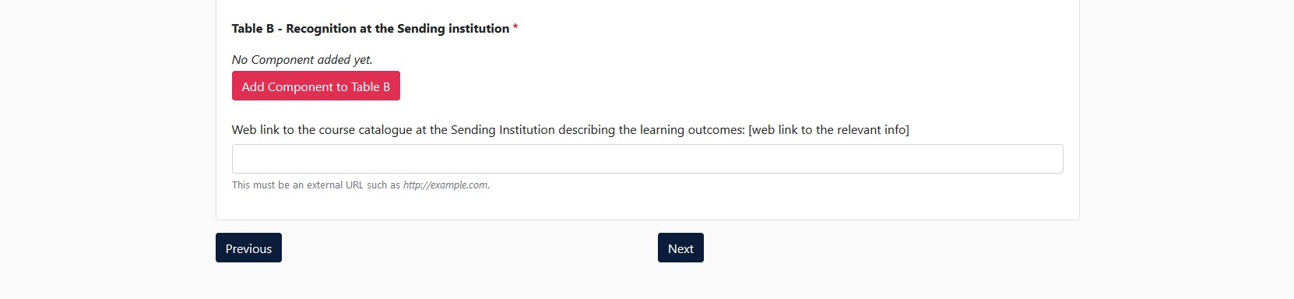
In Table B, please add the subjects that you would have taken in your home institution by clicking on Add Component in Table B.

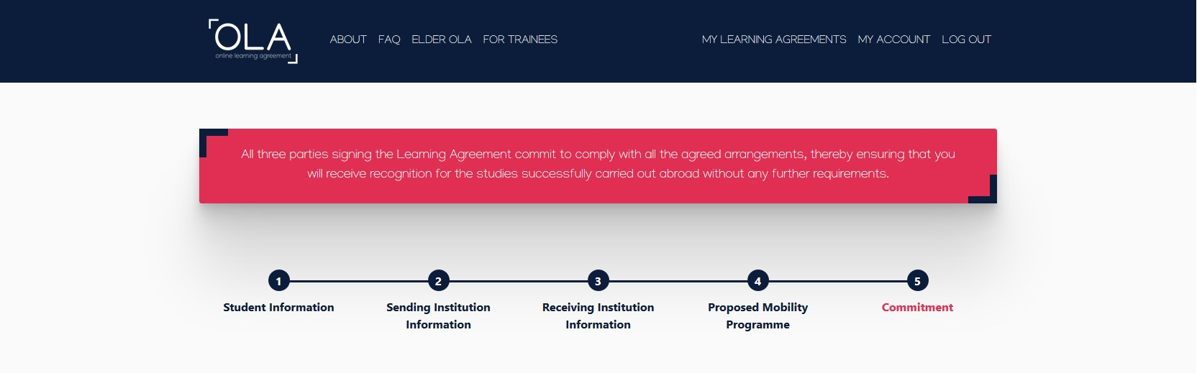

You are about to finalise your OLA.

After checking the information you provided on your OLA, you can now sign it.
It will be automatically sent to the Responsible person at your home institution.
Once he/she signs it, it will be automatically sent to us.

Any question regarding the platform can be addressed to cecile.lafani@univ-paris1.fr

